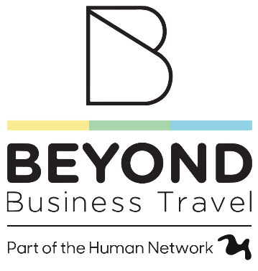


Travel Operations Administrator

Summary of Role

This new role supports the operations manager with sales invoicing and customer service duties, providing an opportunity for career growth in a dynamic and innovative company. The position involves training and mentoring to advance in the team, ideal for someone interested in business, numbers, and technology. You will have the chance to contribute to process improvements, client feedback initiatives, and event coordination, offering a varied and engaging role.

Company Overview

Beyond Business Travel is a leading travel management company serving the UK and Ireland, known for its focus on travel technology and exceptional service for corporate clients. With offices in Belfast and Dublin, they offer a hybrid work environment, competitive benefits, and a vibrant team culture.

Why Work for Beyond Business Travel
- Exciting opportunities in a growing company with a focus on the latest travel technology.
- Hybrid working.
- Competitive salary and benefits (Healthcare Plan, career plan, training).
- Social team atmosphere with events.

Key Responsibilities
- Process and verify data, post invoices, and handle after-sales, including refunds.
- Handle commissions and perform related analysis.
- Communicate with the team to amend bookings and manage client queries.
- Respond to email queries from customers, suppliers, and internal team members.
- Client Surveys & Feedback
- Process Improvement in identifying inefficiencies or bottlenecks in the operations workflow.
- Event Coordination
- Contribution to business reporting and metrics and deadlines
- Assist the line manager with other duties.

Required Skills and Experience
- 3+ years in an office or customer service role.
- Strong telephone, numeracy, and literacy skills.
- Proficiency in Excel, Word, and PowerPoint (intermediate Excel experience required).
- High attention to detail and a friendly, approachable attitude.
- Ability to work independently and as part of a team.
- Experience with a CRM system (desirable).
- Experience in the travel, tour operator, or hotel office environment (desirable).

How to Apply:
Send your CV to HR@beyondbusinesstravel.com. All applications will be treated confidentially.

