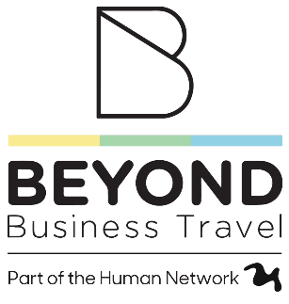

Senior Business Travel Consultant

Groups Experience
About the company
Beyond Business Travel is changing the world of business travel. We are a dynamic, innovative, and fast-growing travel management company based in Belfast & Dublin with expansion onto the UK Mainland in 2025. As part of our acquisition by The Human Network in late 2024, we have big growth plans which means that we need to strengthen our team with new colleagues.

Position Summary
Join our dynamic team as a Senior Business Travel Consultant, where you'll play a pivotal role in managing complex travel arrangements for our corporate clients. This position is ideal for someone who excels in multitasking and has a deep understanding of travel. This hands-on role requires a quick learner with a passion for travel.

Key Responsibilities
- Manage complex group travel arrangements for corporate clients, including flights, hotels, transfers, and ancillary services.
- Create and manage multi-sector, multi-passenger bookings using a GDS (preferably Amadeus), ensuring accuracy and efficiency.
- Build, price, and issue group fares manually, ensuring correct fare construction and compliance with airline contracts.
- Handle all ticketing requirements including group ticketing, reissues, exchanges, refunds, and manual fare builds as required.
- Liaise with airlines, hotels, and suppliers to secure group allocations, negotiate rates, and manage deadlines for deposits, names, and final payments.
- Accurately maintain and update reservations in internal systems and ensure all travel documentation is compliant and timely.
- Proactively manage itinerary changes, disruptions, and complex rebooking’s while minimising cost and inconvenience to the client.
- Provide a high level of customer service to VIPs, senior travellers, and key stakeholders within each group.
- Support junior colleagues with training and oversight, particularly in fares, ticketing, and GDS usage.
- Collaborate with Account Management and Operations to provide data insights, reconciliation support, and feedback post-travel.
Requirements:
- 5 years’ experience in corporate or group travel within a (TMC) or similar.
- Advanced GDS skills (Amadeus preferred), including experience in manual fare building, ticketing, and reissues.
- Strong understanding of published, nett, and group fares, including fare construction principles and IATA ticketing rules.
- Proven experience managing group travel logistics, including negotiations with airlines and suppliers.
- Exceptional attention to detail, with the ability to manage multiple complex files simultaneously.
- Excellent communication skills – both verbal and written – with a professional, client-focused approach.
- Organised, solution-oriented, and able to thrive in a high-pressure, fast-paced environment.
- Travel and Tourism qualification (desirable).
- Experience with MICE bookings, film & media group logistics, or event travel planning.

Compensation and Benefits

- Competitive base salary
- Comprehensive benefits package
- Professional development opportunities

Join our dynamic team and make a significant contribution to our success. To apply, please submit your CV to HR@beyondbusinesstravel.com

